CO

concentration. Observed atmospheric temperature changes show a ﬁngerprint much

2

continued

Learn more about other human causes of climate change:

In addition to emitting greenhouse

Earth’s surfaces (affecting how much

reﬂecting sunlight back to

gases, human activities have also

sunlight is sent back into space) and

space. Some aerosols also affect

altered Earth’s energy balance through,

by changing how wet a region is.

the formation of clouds, which

for example:

can have a warming or cooling

■

Emissions of pollutants (other than

effect depending on their type and

■

Changes in land use. Changes in the

greenhouse gases). Some industrial

location. Black carbon particles (or

way people use land — for example,

and agricultural processes emit

“soot”) produced when fossil fuels

for forests, farms, or cities — can

pollutants that produce aerosols

or vegetation are burned generally

lead to both warming and

(small droplets or particles

have a warming effect because they

cooling effects locally by

suspended in the atmosphere).

absorb incoming solar radiation.

changing the reﬂectivity of

Most aerosols cool Earth by

Earth’s surface and vertically in the atmosphere) compared to that induced by an increase in

in the Sun’s energy output will lead to a very different pattern of temperature change (across

closely at geographical and temporal patterns of climate change. For example, an increase

scientists probe beyond changes in the average temperature of the planet and look more

on climate lead to different patterns seen in climate records. This becomes obvious when

Fingerprinting is a powerful way of studying the causes of climate change. Different inﬂuences

received by Earth, have been enough to trigger the ice age cycles of the past 800,000 years.

variations in Earth’s orbit around the Sun, which alter the distribution of solar energy

typically about two to three years. Over hundreds of thousands of years, slow, recurring

stratosphere that reﬂect or absorb sunlight, leading to a short-term surface cooling lasting

eruptions also alter climate, in part increasing the amount of small (aerosol) particles in the

year-to-year regional and global shifts in temperature and rainfall patterns. Volcanic

(lasting about two to seven years) in the equatorial Paciﬁc Ocean that causes signiﬁcant

Niño Southern Oscillation (ENSO), an irregular alternation between warming and cooling

global scale, on timescales from days to decades and longer. One natural variation is the El

variations that affect temperature, precipitation, and other aspects of climate from local to

In order to discern the human inﬂuence on climate, scientists must consider many natural

requires a signiﬁcant role for the inﬂuence of human activities.

warming over the past 50 years or so cannot be explained by natural causes and instead

Rigorous analysis of all data and lines of evidence shows that most of the observed global

Human activities are changing the climate.



Source: Based on IPCC AR5

period (set to zero) of 1986-2005.

All data are relative to a reference

projected by the different models.

between the temperature changes

the spread (one standard deviation)

shaded areas provide a measure of

same emissions scenario, and the

of different model runs using the

solid line represents the average

estimate of past warming. Each

now (in blue). Black is the modelled

falling close to zero 50 years from

aggressive emission reductions,

emissions scenario (in red) and

ture increase for a business-as-usual

emits. Models project the tempera-

greenhouse gases that humankind

tury depends on the total amount of

warming expected for the 21st cen-

The amount and rate of

Figure B.

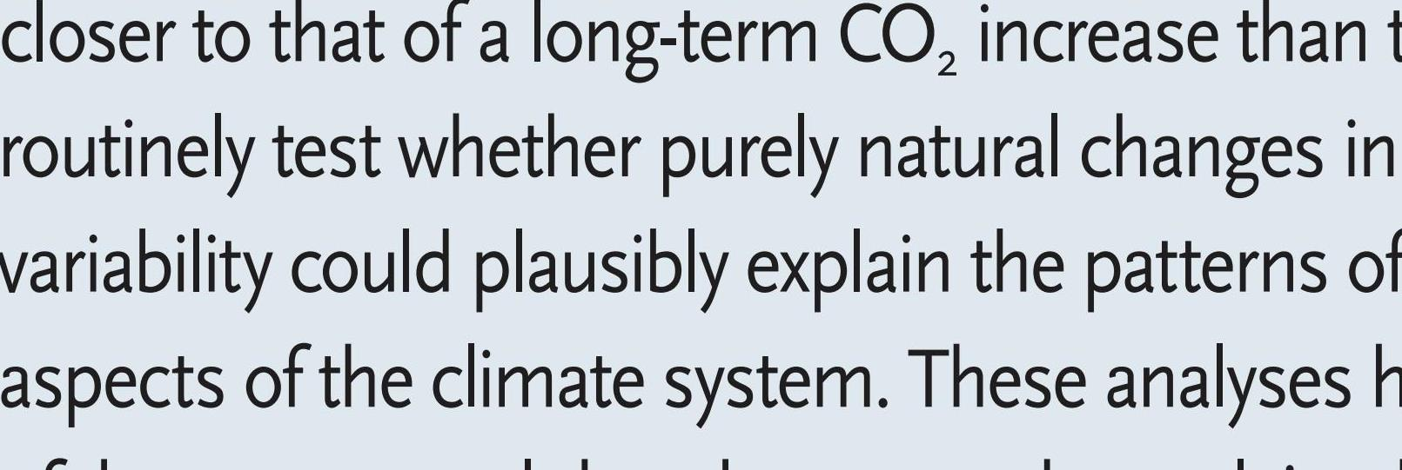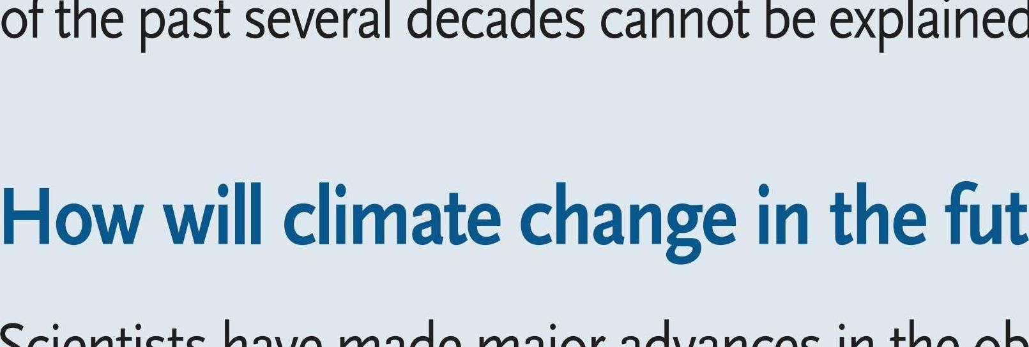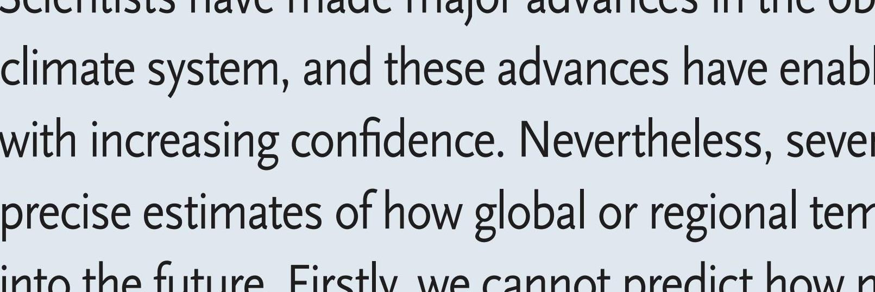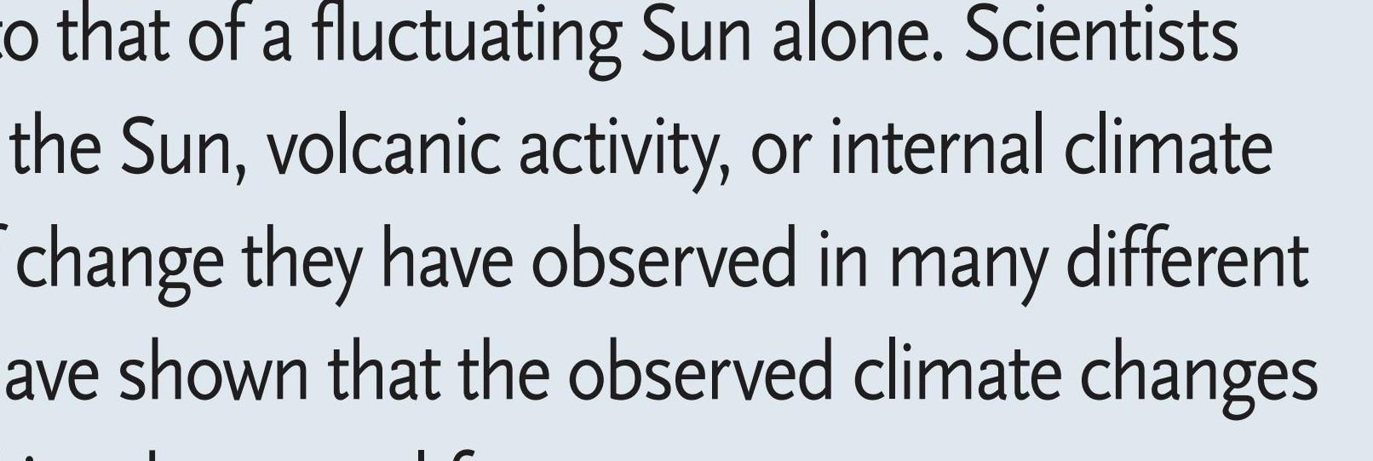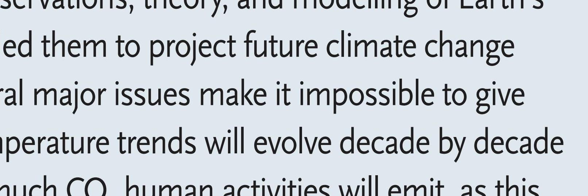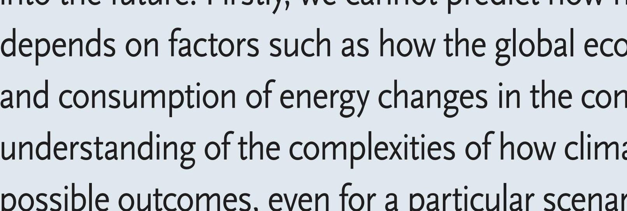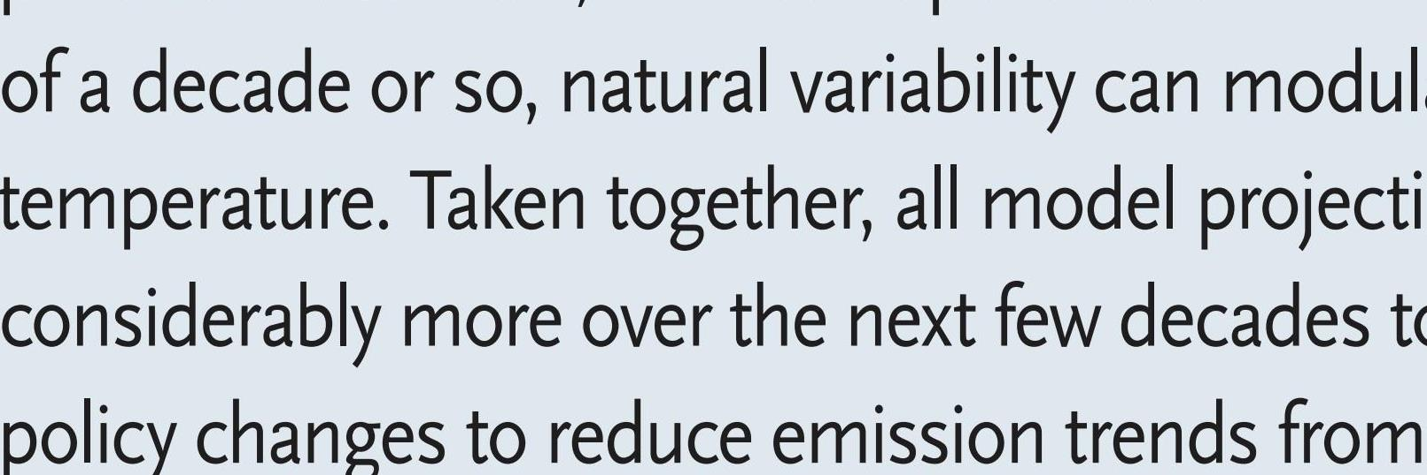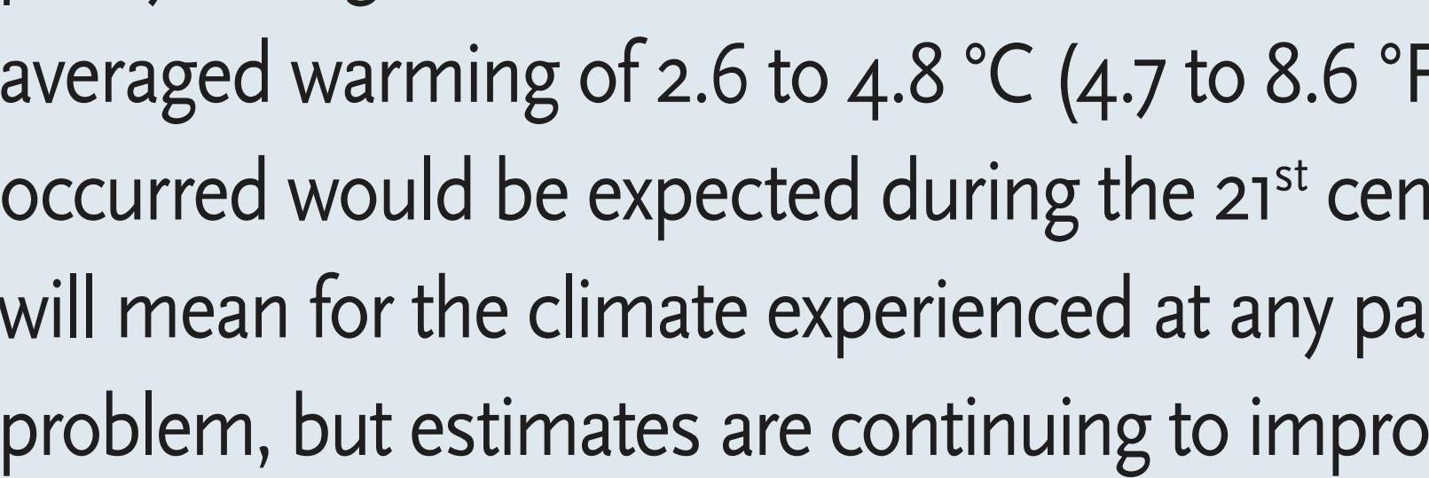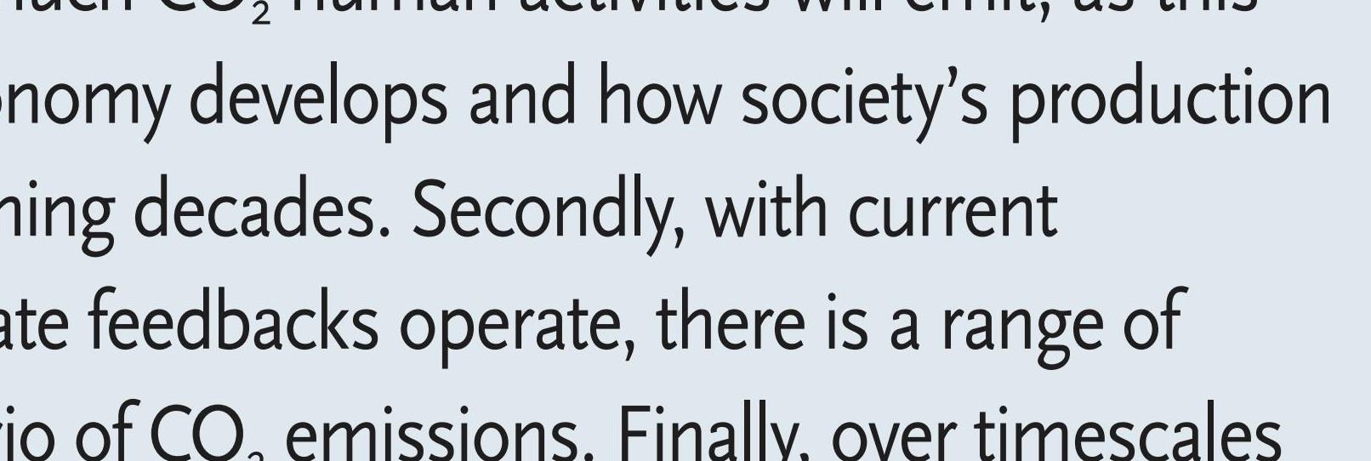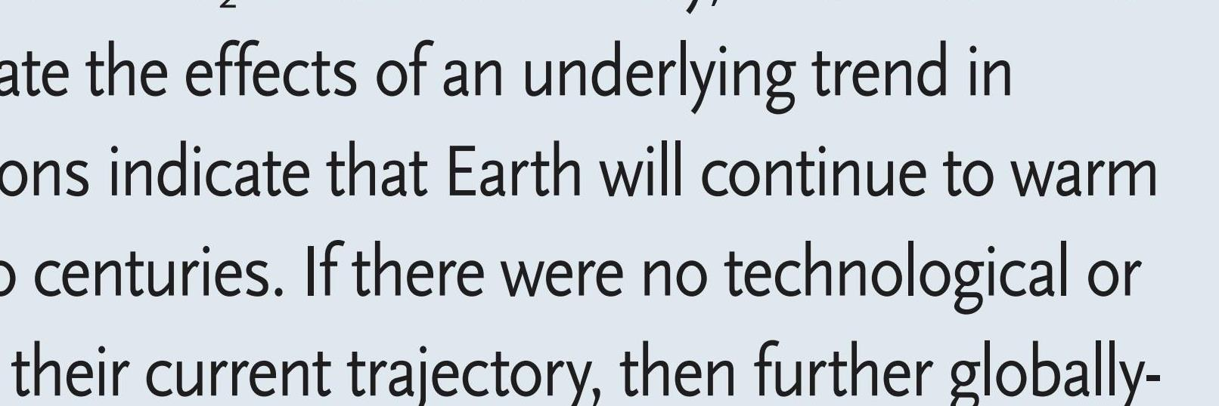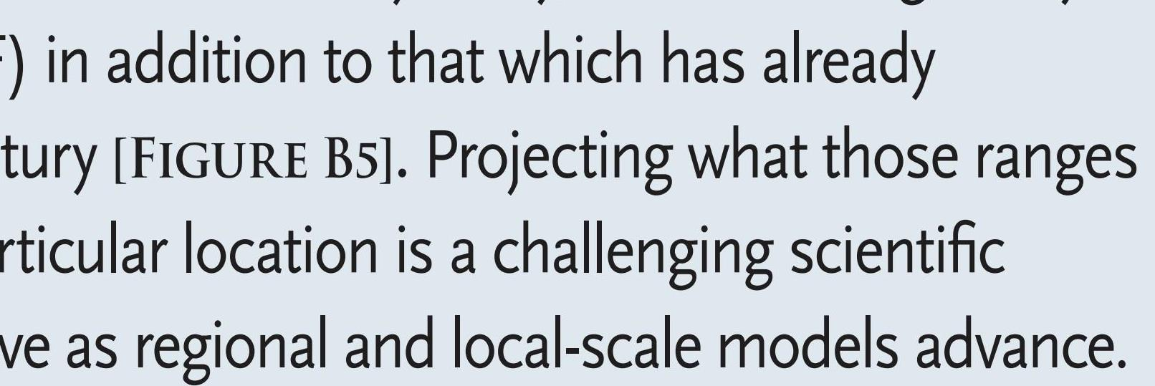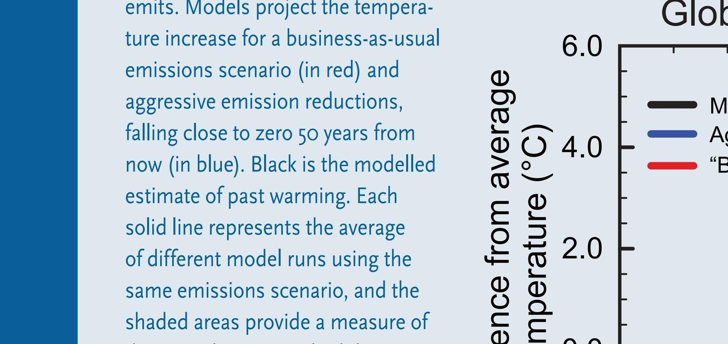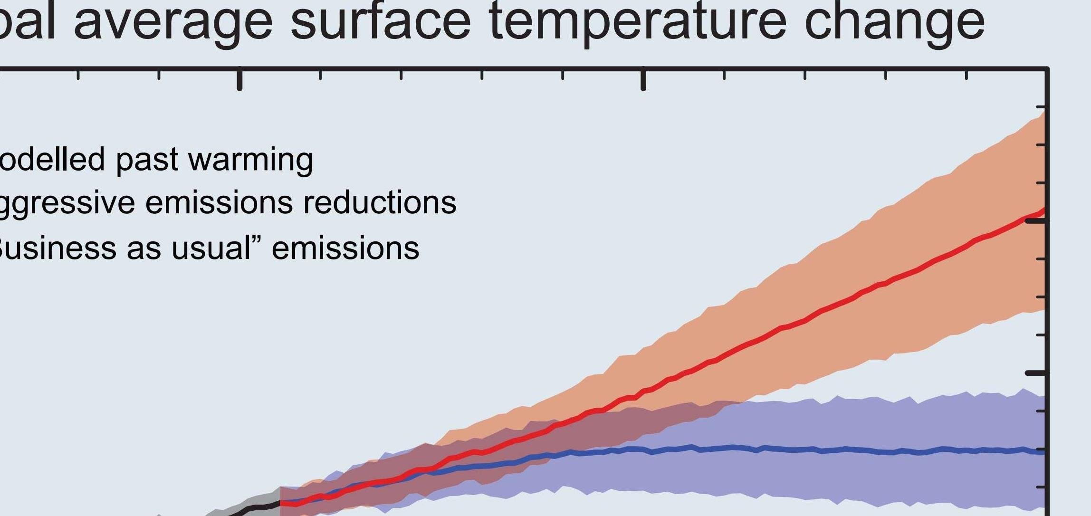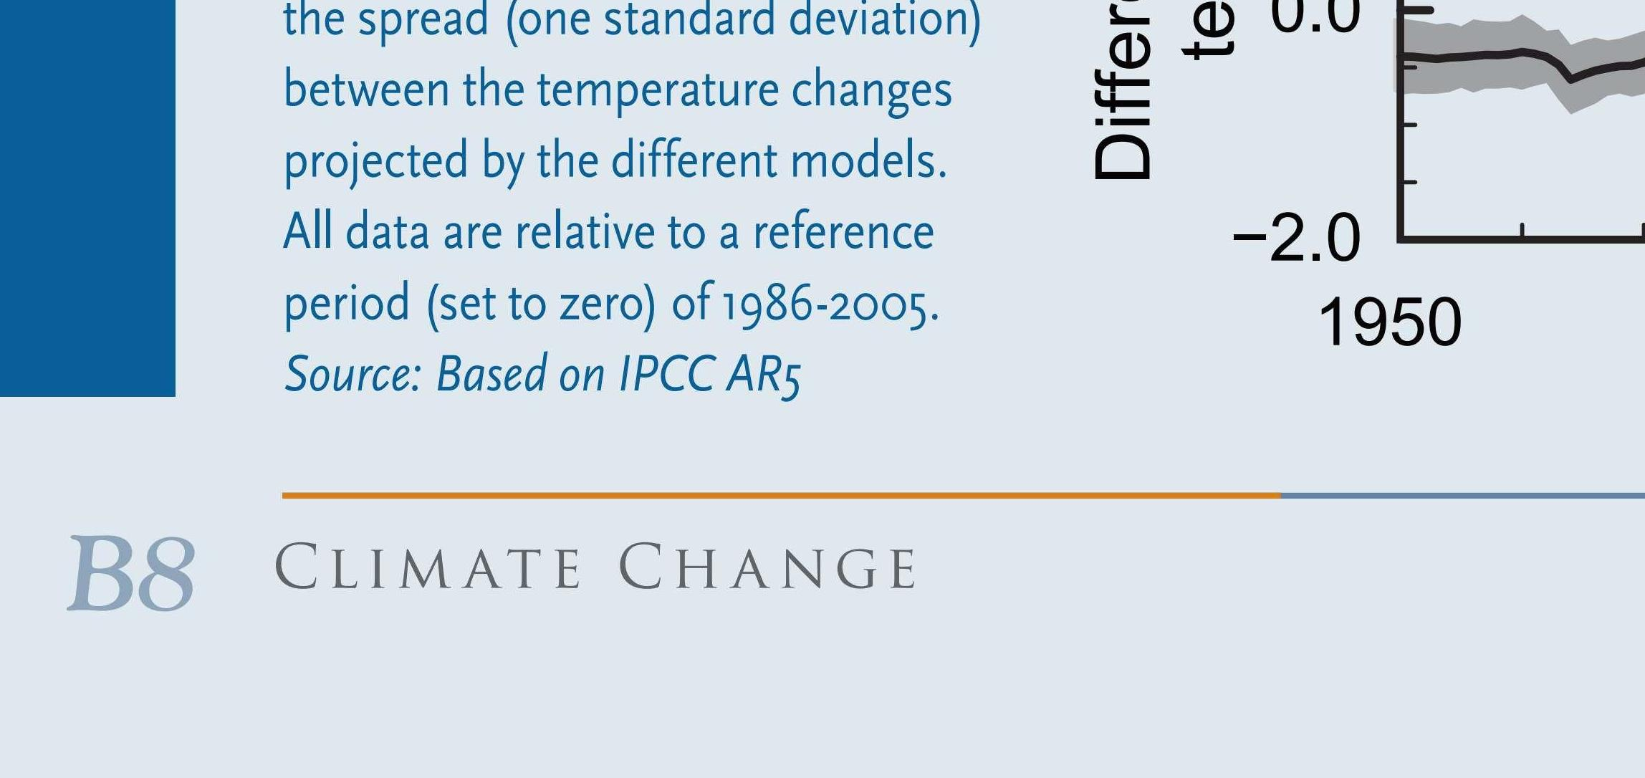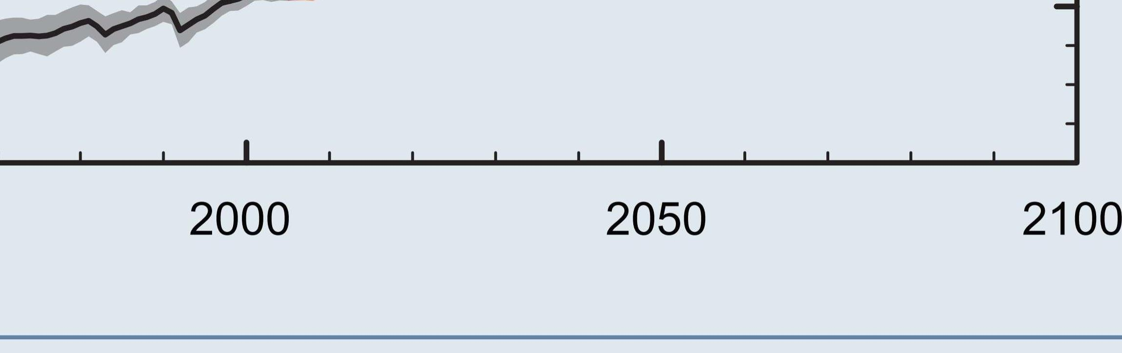

13

Evidence & Causes 2020

Australia. Marine heat waves are also increasing.

recent decades heatwaves have increased in frequency in large parts of Europe, Asia, South America, and

twice as many record highs as record lows. Another important example of tilting the odds is that over

there were more daily record low temperatures than record highs, but in the 2000s there were more than

seasons and fewer cold days and seasons. For example, across the continental United States in the 1960s

and many other aspects of the weather. Global warming tilts the odds in favour of more warm days and

Atmospheric and ocean circulation patterns will evolve as Earth warms and will inﬂuence storm tracks

tion has contributed to several recent cold winters in Europe, eastern North America, and northern Asia.

the persistence of one phase of an atmospheric circulation pattern known as the North Atlantic Oscilla-

cooler. Stronger winds from polar regions can contribute to an occasional colder winter. In a similar way,

Niña events shift weather patterns so that some regions are made wetter, and wet summers are generally

atmospheric circulation, in the size and patterns of natural climate variations, and in local weather. La

Climate change means not only changes in globally averaged surface temperature, but also changes in

even as the climate warms.

will continue to produce some unusually cold days and nights and winters and summers,

warmer than the previous one. Day-to-day and year-to-year changes in weather patterns

Global warming is a long-term trend, but that does not mean that every year will be

11

winters and summers still very cold?

If the world is warming, why are some

Q& A n

